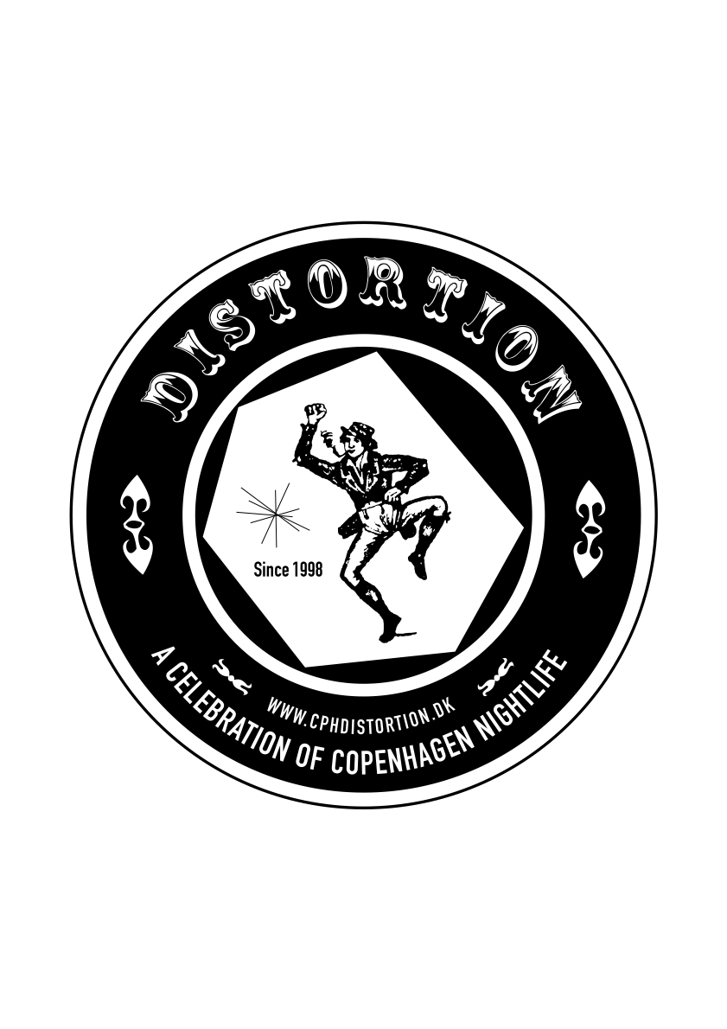
Wed.7.May.08

Distortion 2008
http://www.cphdistortion.dk
4-8 Juni 2008
56 lovely parties in 56 spectacular locations

CLUB CLASH - the ultimate battle with the true party-maestros of Europa.
A selection of crazy party makers from London, Paris, Milan, Berlin and Malmö, will be gathered in Copenhagen for 5 days – at what can be described as the wildest arena of hardcore party animals ever seen. Not because they are hot, not because they are cool, just because they do their thing their own way – and because they (hopefully) understand what they do with a smile.
Of course, this is far from the biggest party of all time – but each club, hand-picked as the very hardest clubs among Europe’s very hottest cities, is coming over with (at least) 20 of its favourite party animals. As far as European club-culture is concerned, it’s unique.

CLUB CLASH 2008 contestants:
RIO REVIVAL (Berlin) + EASY JETSET (Berlin) + PARIS PARIS (Paris) + DIRTY (Paris) + Wet Yourself (London) + VICE Magazine (London / Stockholm / Copenhagen)
+ Culture Box & KillYourTelly + The Rumble (Malmö) + AiAiAi / Tartelet (Amager)

CLUB CLASH 2008 RULES?
-not really.

Main Sposnor: Tiger Beer
Support from: Københavns Kommune, Kunstrådet
Special Sponsors: Ben & Jerry’s, Roskilde Festival, Wonderful Copenhagen, Ørestad

Contact
DISTORTION // HUMAN OFFICE // Tel (+45) 30 25 50 10 // info@cphdistortion.dk.
PRESS CONTACT: Åsmund Kverneland // Tel (+45) 26 20 35 90// press@cphdistortion.dk

The company behind Distortion: Nus/Nus – cultural network
http://www.nusnus.dk
Info + pictures + background:
http://www.cphdistortion.dk
