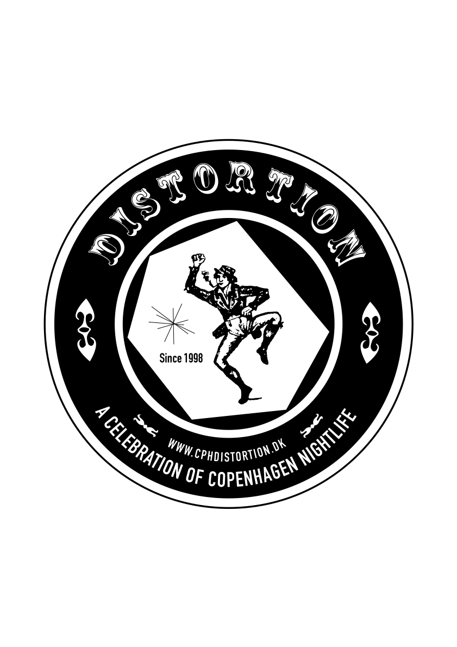
Wed.7.May.08

Distortion 2008
http://www.cphdistortion.dk
4-8 Juni 2008
56 lovely parties in 56 spectacular locations

Copenhagen's streetlife & nightlife festival
Founded in 1998, Distortion is a leading force within Copenhagen's party, street, fashion and music culture.
From Pig in Italy to Colette in Paris or Vice in London, we are known as one of the hardest festivals in Europe for big-city trends.
Taking place on the first weekend of June as a five days & nights mobile feast, Distortion invades one Copenhagen district per day
where 56 local and international icons of street & club culture host one party each.

This year the new thing is the Club Clash – see special press release.

Find pictures, videos and more on www.cphdistortion.dk/info
The 2008 programme is released Friday 9 May on www.cphdistortion.dk

Main Sponsor: Tiger Beer
Support from: Københavns Kommune, Kunstrådet
Special Sponsors: Ben & Jerry’s, Roskilde Festival, Wonderful Copenhagen, Ørestad

Contact
DISTORTION // HUMAN OFFICE // Tel (+45) 30 25 50 10 // info@cphdistortion.dk.
PRESS CONTACT: Åsmund Kverneland // Tel (+45) 26 20 35 90// press@cphdistortion.dk

The company behind Distortion: Nus/Nus – cultural network
http://www.nusnus.dk
Info + pictures + background:
http://www.cphdistortion.dk

